**Sophia Girls' College (Autonomous),  
Ajmer  
Affiliated to the MDS University, Ajmer**

**BCA**

**(2022-23)**

**Project Report**

**Online CR Voting System**

**Submitted To: Submitted By:**

**Sir Gautam Chaturvedi Riya Lodha HOD Computer Science Roll No: 2007403**

**Sophia Girls' College (Autonomous),  
Ajmer  
Affiliated to the MDS University, Ajmer  
  
BCA**

**(2022-23)**

**Project Report**

**Online CR Voting System**



**Submitted To: Submitted By:**

**Sir Gautam Chaturvedi Riya Lodha HOD Computer Science Roll No: 2007403**

**CERTIFICATE**

It is to certify that the work incorporated in the project entitled "**Online CR Voting System**" which has been submitted by **Riya Lodha**, of BCA (Bachelor's in computer science applications) Semester - VI has completed this work sincerely in the prescribed period to the best of my knowledge, it is an original contribution and has not been submitted for any other degree of any University.

**Date:**

**Project Supervisor:  
Dr. Neha Sharma**

Assistant Professor

Sophia Girls' College  
(Autonomous), Ajmer

**DECLARATION**

The Project  
"**Online** **CR Voting System** "  
developed by **Riya Lodha**  
of BCA (Bachelor's in computer science application)Semester - VI  
has been examined on  
______________  
in partial fulfillment for a degree in

BCA (Bachelor's in computer science)  
and the facts specified in this report are  
true to the best of our knowledge.

(Internal Examiner) (External Examiner)

**ACKNOWLEDEGMENT**

Exchange of ideas generates energy and will to work in a better way whenever it is helped and cooperated by others. I wish to take this opportunity to express my thanks to all those who have directly or indirectly contributed to this project. I extend my deep sense of immeasurable indebtedness to my guide Dr. Neha Sharma for being a source of information and for her constant support in the design, implementation, and development of my Project: "Online CR Voting System". I am extremely grateful to her for her constant criticism and invaluable advices that helped in the development of my project.

**CONTENTS**

1. **ABSTRACT**
2. **INTRODUCTION**
3. **SYSTEM ANALYSIS**

3.1 HARDWARE & SOFTWARE REQUIREMENT

3.2 LANGUAGES USED

1. **SYSTEM DESIGN**  
    4.1 TABLE STRUCTURE
2. **SYSTEM IMPLEMENTATION**  
    5.1 MODULE DESCRIPTION  
    5.2 CODE
3. **CONCLUSION**
4. **BIBLIOGRAPHY**
5. **REMARKS**

**ABSTRACT**

PHP Online CR Voting System has been built by using PHP with MySQL database and HTML provides the basic structure of sites, which is enhanced and modified by other technologies like CSS, Bootstrap and JavaScript. CSS is used to control presentation, formatting, and layout. Bootstrap is used for creating responsive websites by providing pre-built components. JavaScript is used to control the behavior of different elements.

The main aim of developing CR Voting System is to facilitate fair and anonymous elections in our college. This system is an efficient way for voters to participate in the voting process while ensuring the confidentiality and security of each vote.

It aims to eliminate the problems that come with traditional voting systems such as vote manipulation, ballot stuffing, and intimidation of voters. In a college environment, the online voting system is particularly relevant as it allows students to cast their vote in a convenient and secure manner and enables them to take part in shaping the future of their college.

This Online CR Voting System ensures anonymity by keeping the voter's identity confidential. The system also ensures that each voter can only vote once, and it prevents double voting or any attempt to manipulate the vote count. It is designed to ensure that each student can exercise their right to vote without fear of intimidation or coercion.

Once the voting process is complete, the system generates a statistical data that summarizes the results. The system provides a secure and transparent way to count the votes, and it ensures that the outcome is fair and legitimate.

**INTRODUCTION**

Our modern age of technology is greatly dependent on the internet. An online system is also known as a Web-based system. As the world is growing so fast so there is always a desire to communicate faster and effectively. The main focus was to provide an efficient and secure way for students to participate in the election process, promoting transparency and fairness in the vote count, and increasing student engagement and participation in college governance.

The objectives of creating an Online CR Voting System were:

* To eliminate the problems associated with traditional voting systems such as vote manipulation, ballot stuffing, and intimidation of voters.
* To provide a secure and confidential way for students to exercise their right to vote without fear of retaliation or coercion.
* To ensure that each student can only vote once, and prevent any attempt to manipulate the vote count.
* To increase participation in the voting process by making it convenient and accessible to all students.
* To generate a report that summarizes the results and provides relevant statistics, ensuring transparency and fairness in the vote count.
* To stream line the voting process & reduce administrative burden associated with traditional voting systems.

**SYSTEM ANALYSIS**

**3.1 HARDWARE & SOFTWARE REQUIREMENTS**

A simple Personal Computer with optimum hardware & software configuration was next requirements. The Personal Computer of following hardware configuration should be there:

*Hardware Requirements:*

* Processor-Dual Core
* Ram-2 GB
* Hard Disk Drive-Minimum 512 MB

*Software Requirements:*

* PHP Server (WampServer / Xampp)
* Windows (XP & above)

**3.2 LANGUAGES USED**

* PHP: It is a server-side scripting language used for web development. It is an open-source language that can be embedded into HTML and used to build dynamic web pages
* CSS: CSS stands for Cascading Style Sheets and is used for styling web pages. It is a markup language that is used to control the layout, fonts, colors, and other design aspects of a website. It is used in conjunction with HTML and JavaScript to create interactive and visually appealing websites.
* JavaScript: It is a client-side scripting language that is used to add interactivity and functionality to web pages. It is a high-level programming language that is used for front-end web development. JavaScript can be used to validate forms, create animations, and perform other dynamic functions on a website.
* Bootstrap: It is a popular front-end web development framework used for creating responsive, mobile-first websites. It provides a set of pre-designed CSS styles, JavaScript components, and HTML templates that make it easier to build consistent, visually appealing, and user- friendly web pages.

**SYSTEM DESIGN**

When we design software or a system, we consider some requirements to make the project efficient.  
I have tried to build a user friendly web application. This user interface of this system is very simple that everyone can use it without facing any problem.  
For better explanation, I have drawn business process models, used case diagram, activity diagram and logical data model.  
I have used MySQL for designing the database. For front end design I have used HTML & CSS. I have used PHP for back end design.

**Front-end Design**  
The front end normally designed by two parts. The web design and front end web development.  
I have used HTML, CSS, Bootstrap and JavaScript for the front end design.

**Back End Design**  
The backend is normally designed by three parts: a server, an application and a database. User input the data that is needed by application & it is stores it in databases that are created on a server.

**TABLE STRUCTURE**

tbl_users

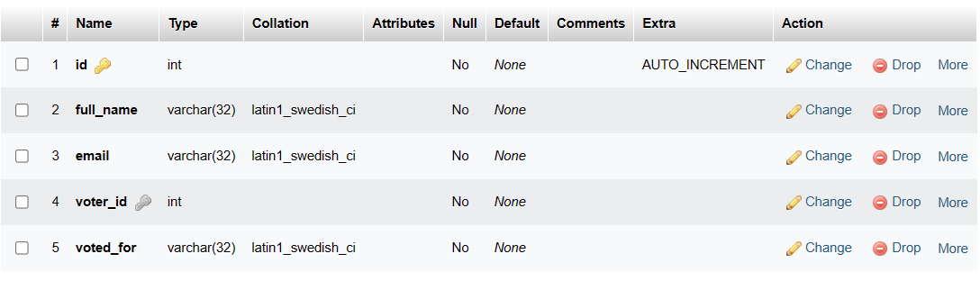

tbl_admin

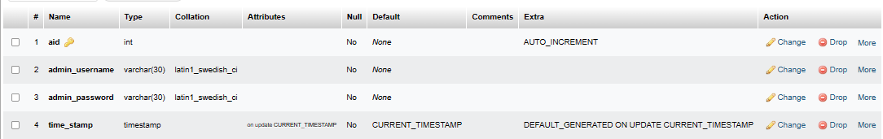

**SYSTEM IMPLEMENTATION**

The list of implementation requirement is given below:

* Easy to create
* Easy to interact
* User-friendly
* Dynamic pages
* Easy to manage

**5.1 MODULE DESCRIPTION**  
This website is used by two types of users:-

* Voter
* Voter can register themselves & cast their vote to the nominee.
* Admin
* Admin can check the results through the statistical report.
* Admin can see the details of the nominees.
* Admin can change his/her password, if needed.

**HOME PAGE**

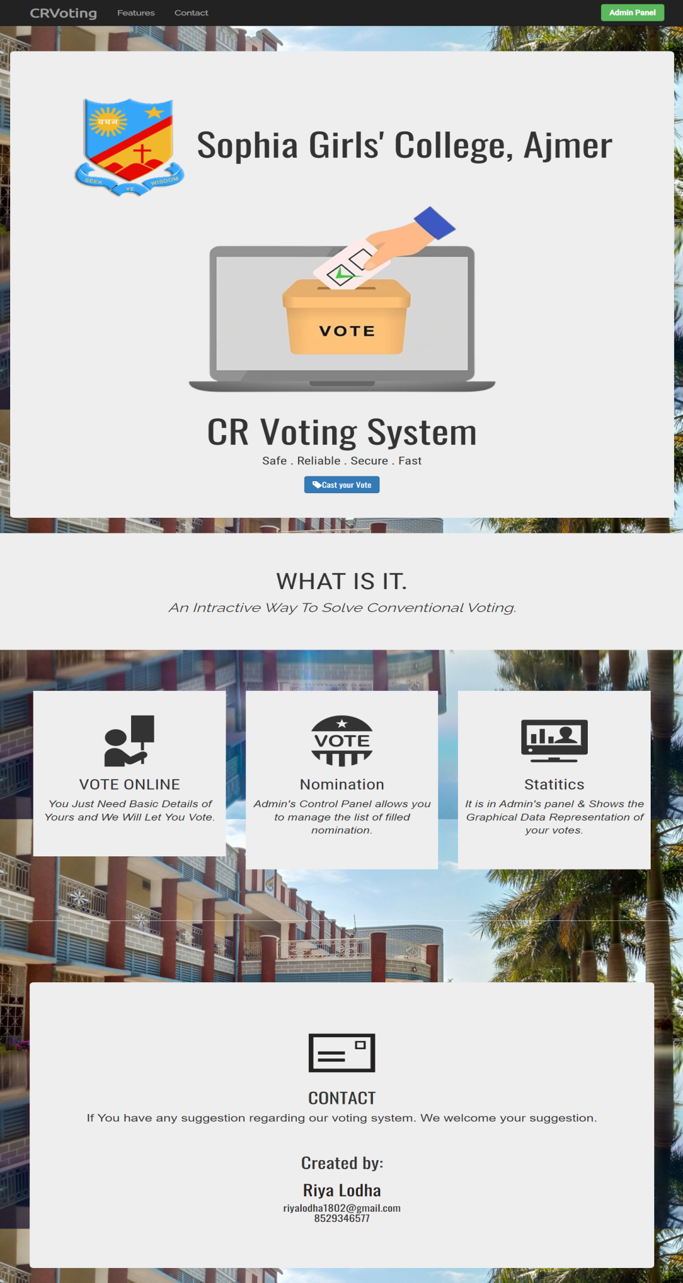

The first page of the Online CR Voting System website is designed with user convenience and simplicity in mind. The page is divided into three parts, each serving a specific purpose.

The first part of the webpage features the college logo, which provides a direct link to the college's official website *https://sophia.college/*. This link will allow voters to access relevant information about the college and its activities. In addition, this part of the webpage includes a button that will direct the user to the next webpage, where they can begin the voting process. This button is prominently displayed, ensuring that voters can quickly and easily access the voting page.

The second part of the webpage is dedicated to listing the features of the website. This section is designed to inform the voter about the capabilities of the Online CR Voting System, making it easy for them to understand how the system works. The features include the ability to register to vote, select their preferred nominee, and view the results of the election. This section will be presented in an easy-to-read format, ensuring that voters can quickly and easily understand the features of the website.

The third part of the webpage is dedicated to providing information about the creator of the website. This section is designed to provide users with a means of contacting the creator if they have any questions or concerns. This section will include the creator's name and contact information, as well as a link to their resume. This link will allow users to learn more about the creator and their qualifications, providing additional information and confidence in the system's reliability and security.

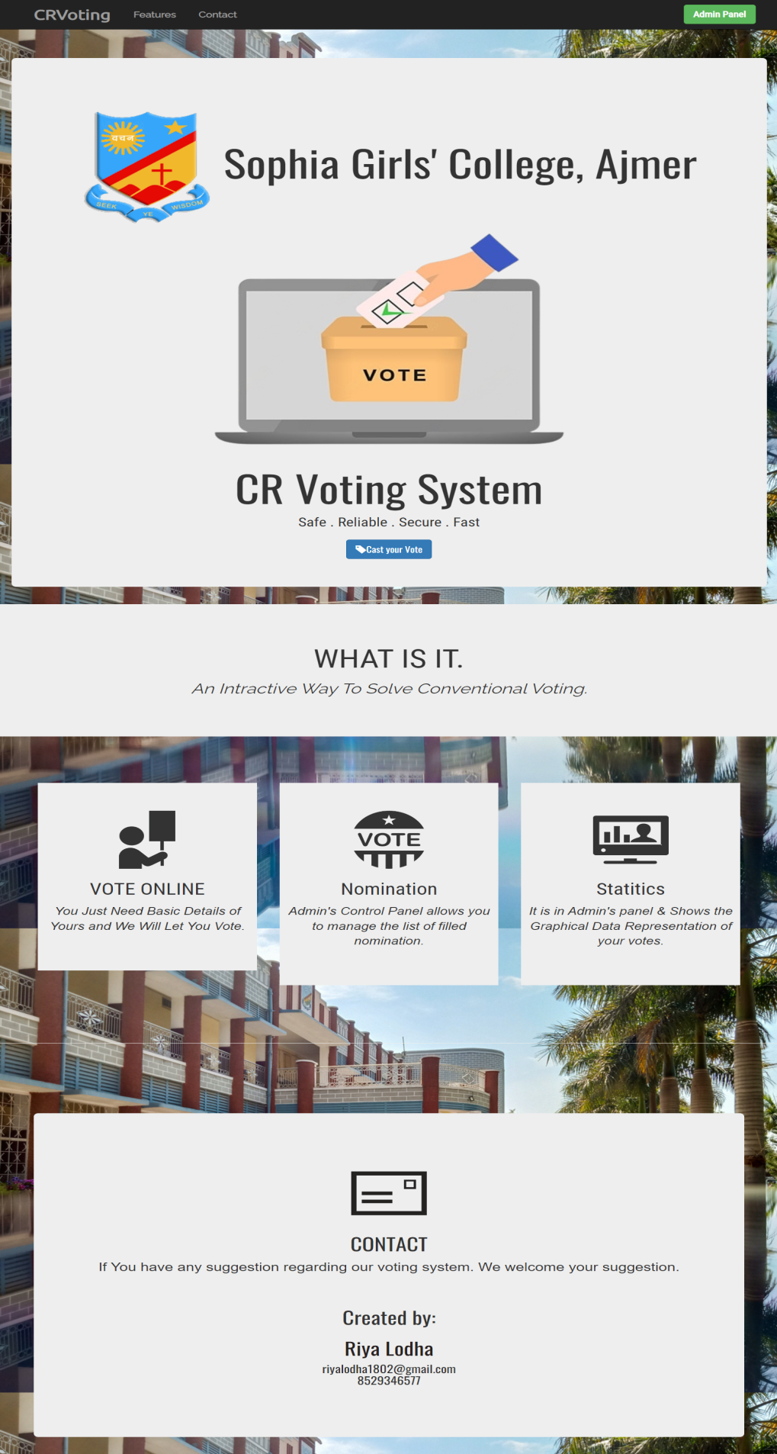1.



2. Features

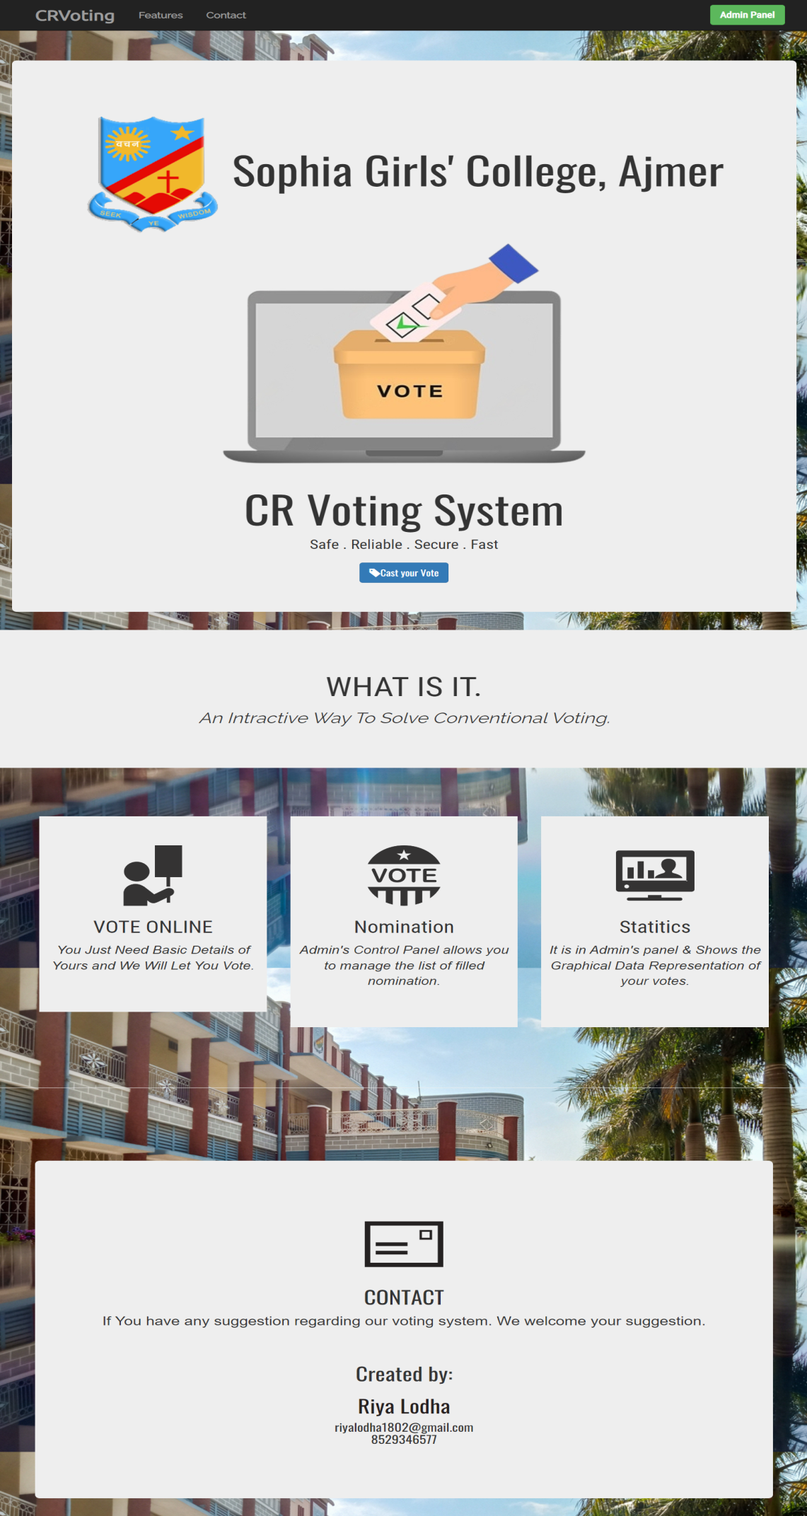

3. Contact

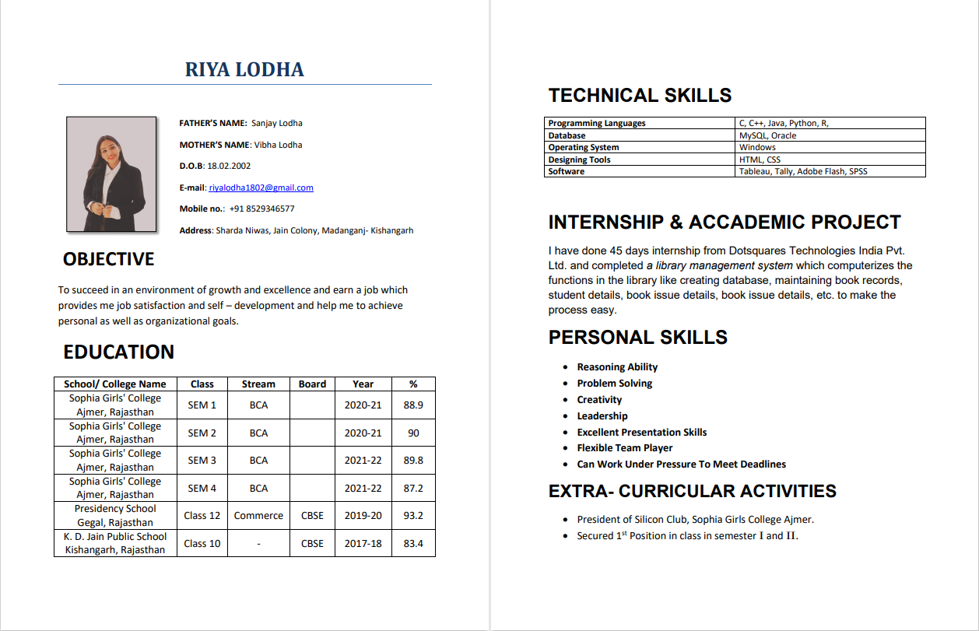

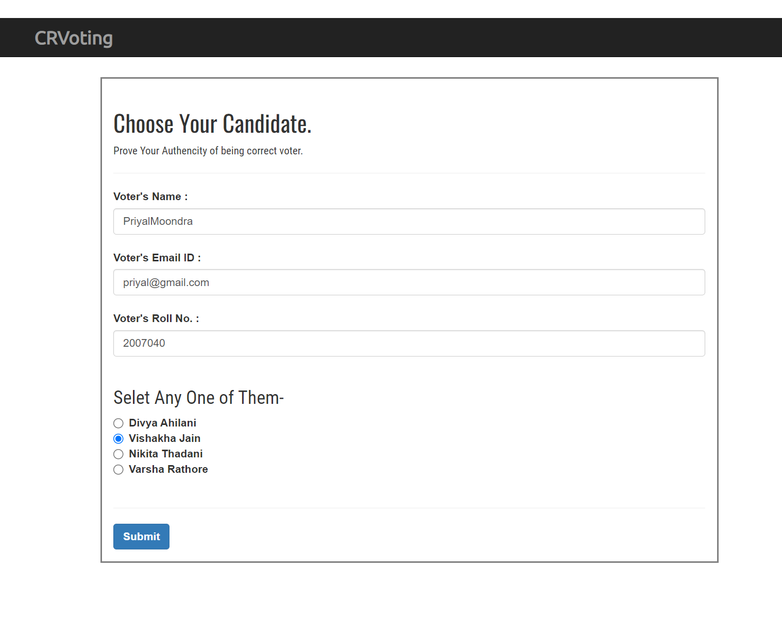**VOTER MODULE**

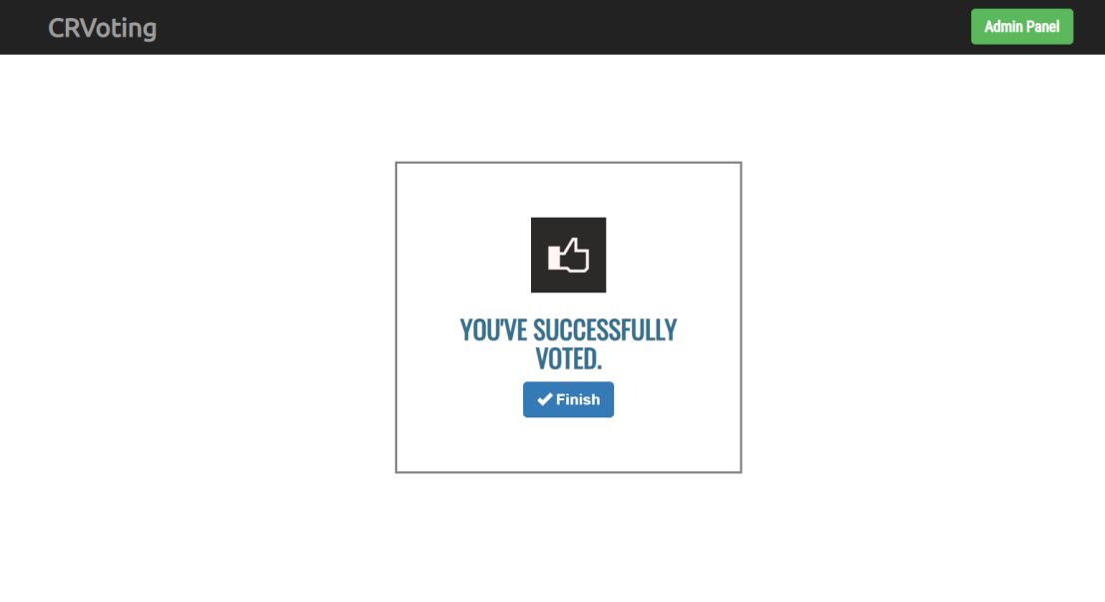

The next webpage in the Online CR Voting System is the registration page, where voters can register themselves by providing their name, email id, and roll number. The webpage is designed in a user-friendly way, making it easy for voters to fill in their details correctly. If any box is left empty or filled with incorrect information, the site will guide the voter to fill in the details again in the correct format.

The page also includes the list of nominees at the end for the voter to choose their nominee to vote. One voter can vote only once, which ensures that the election is fair and accurate. The webpage will not disclose the voter's personal information or their choice of nominee to anyone, ensuring that the election process is fair and anonymous.

**ADMIN MODULE**

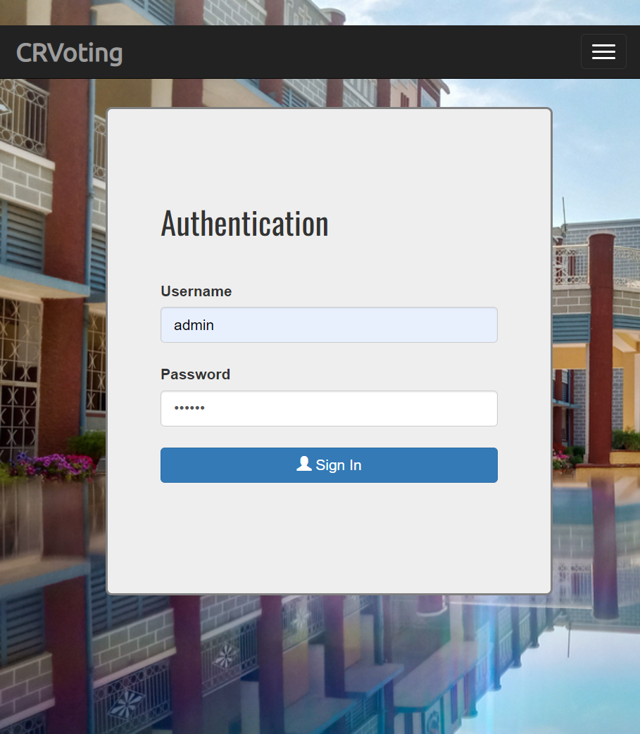

*IF THE PASSWORD IS INCORRECT:***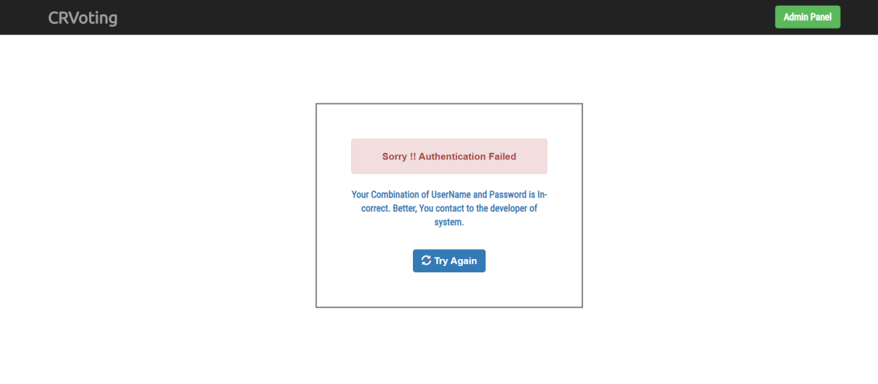**

This page is designed for admin. It requires the admin to enter the correct admin name and password to log in. If the admin enters an incorrect password, a dialog box will appear informing them of the mistake and requesting them to try again with the correct credentials. The admin can access the voting results page, details about nominees & change their password to maintain the security of the system.

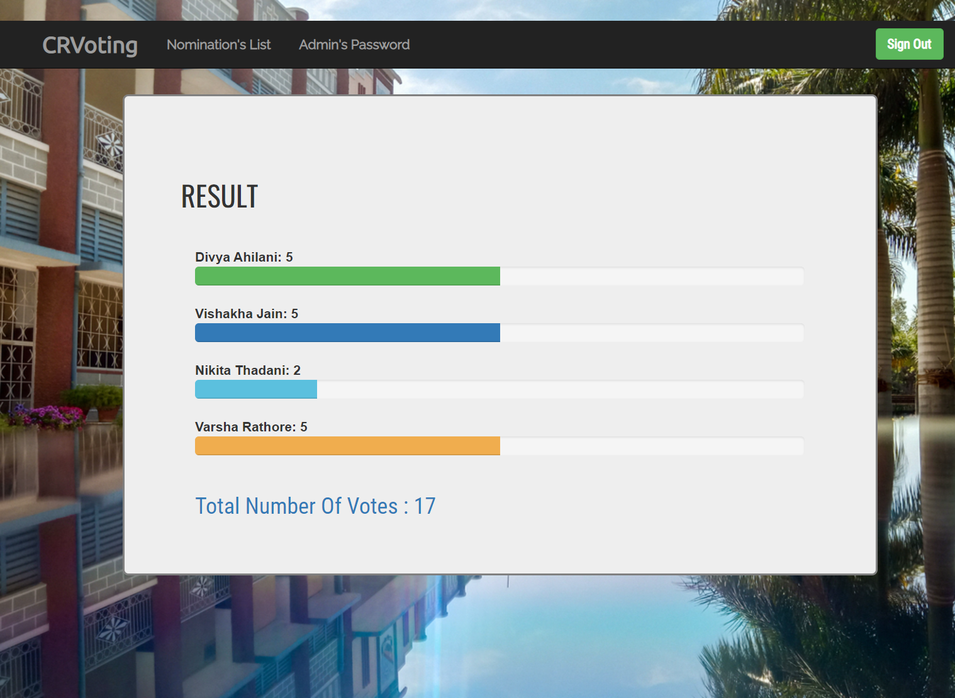**RESULT THORUGH STATISTICAL REPORT**

After successfully logging in, the admin will be directed to a new web page that displays the statistical report of the voting results. This page is designed to provide the admin with a clear and concise overview of the election outcome. The report includes a graphical representation of the votes received by each nominee, along with the number of votes they received. This visual representation makes it easy for the admin to quickly identify the most popular nominee and the overall trend of the voting process. In addition, the report includes the total number of votes cast in the election, providing an accurate measure of voter participation. This statistical report is an important tool for the admin to assess the fairness and transparency of the election process and to identify any potential issues or discrepancies that need to be addressed.

**NOMINATION’S LIST**

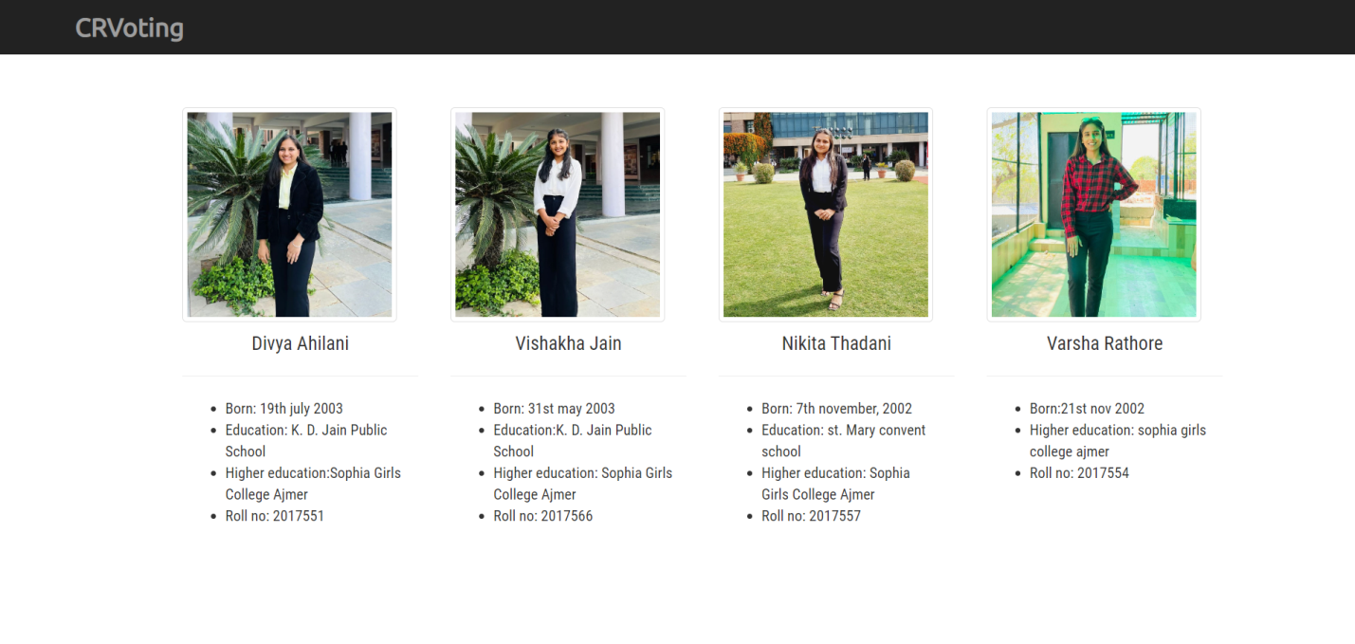

After viewing the statistical report of the voting process, the admin can proceed to the next webpage to view the details of the nominees. This webpage includes the photos of the nominees, their names, date of birth, education details, and roll numbers.

The details of each nominee are presented in an organized manner, with a clear and concise layout. The photos of the nominees are displayed prominently at the top of the page, followed by their names and other personal details.

The admin can use this webpage to gain a better understanding of each nominee and their qualifications. This information can help the admin to make informed decisions and provide guidance to the students on the voting process.

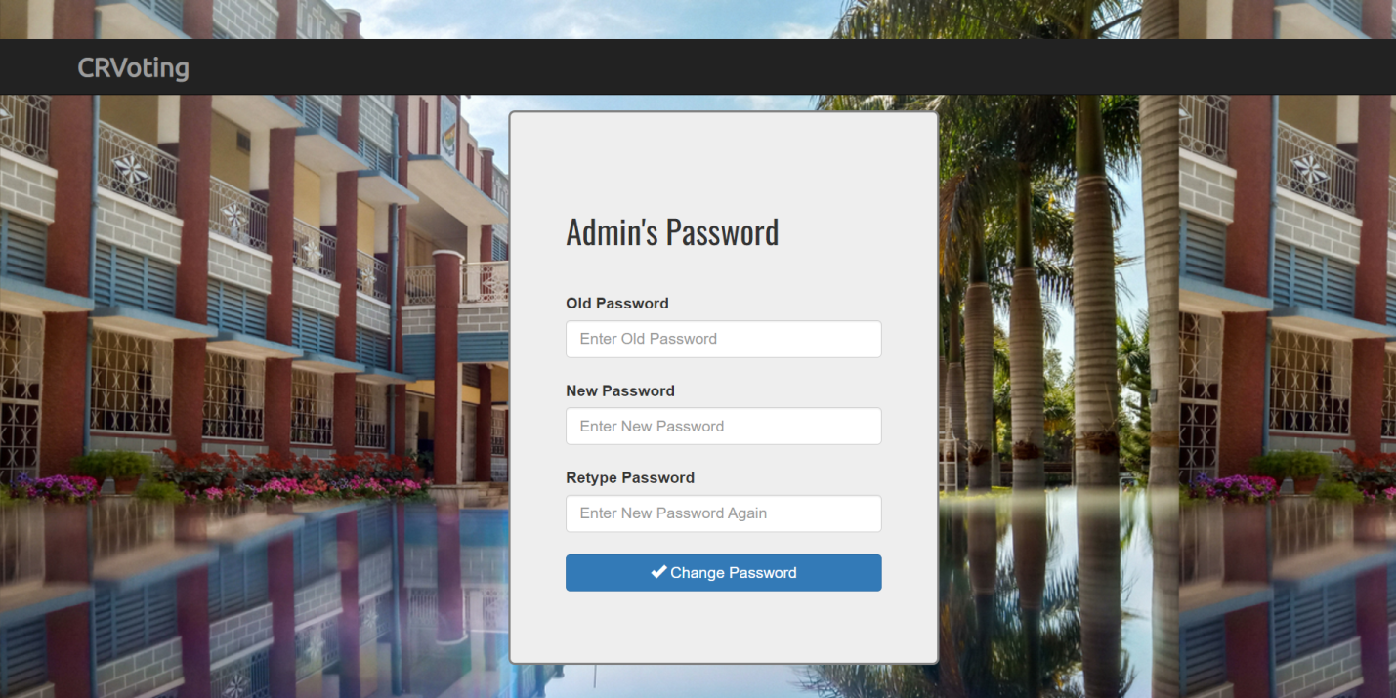**CHANGE PASSWORD**

This page is designed to allow the admin to change their password with ease. The page requires the admin to enter their current password in a designated box, and then enter their new password in two other boxes: one for typing the new password and one for retyping it to confirm it. This is done to prevent the admin from making any errors while typing their new password.

Once the admin has entered all the required information, they can click on the "Change Password" button to update their password. If the current password entered by the admin does not match the existing password, a message will be displayed on the screen informing the admin that the current password is incorrect. This is done to ensure that only authorized users are able to change the password.

After the password has been successfully changed, a message will be displayed on the screen informing the admin that their password has been updated. The admin can then log out of the system or return to the main menu to access other features.

**CODING**

**index.html**

<!DOCTYPE html>

<html lang="en">

  <head>

    <meta charset="utf-8">

    <meta http-equiv="X-UA-Compatible" content="IE=edge">

    <meta name="viewport" content="width=device-width, initial-scale=1">

    <!-- The above 3 meta tags *must* come first in the head; any other head content must come *after* these tags -->

    <title>CR Voting</title>

    <!-- Bootstrap -->

    <link href="css/bootstrap.min.css" rel="stylesheet">

    <link href='http://fonts.googleapis.com/css?family=Ubuntu' rel='stylesheet' type='text/css'>

    <link href='http://fonts.googleapis.com/css?family=Raleway' rel='stylesheet' type='text/css'>

    <link href='http://fonts.googleapis.com/css?family=Oswald' rel='stylesheet' type='text/css'>

    <link href='http://fonts.googleapis.com/css?family=Roboto+Condensed' rel='stylesheet' type='text/css'>

    <style>

    body{

      background-image: url('./images/sophia.jpg');

      margin:0px;

      padding:0px;

    }

      .headerFont{

        font-family: 'Ubuntu', sans-serif;

        font-size: 24px;

      }

      .subFont{

        font-family: 'Raleway', sans-serif;

        font-size: 14px;

      }

      .specialHead{

        font-family: 'Oswald', sans-serif;

      }

      .normalFont{

        font-family: 'Roboto Condensed', sans-serif;

      }

      a {

        color: #FFFFFF;

        text-decoration: none;

      }

      a:link {

        color: #FFFFFF;

        text-decoration: none;

      }

      /* visited link */

      a:visited {

          color: #FFFFFF;

          text-decoration: none;

      }

      /* mouse over link */

      a:hover {

          color: #FFFFFF;

          text-decoration: none;

      }

      /* selected link */

      a:active {

          color: #FFFFFF;

          text-decoration: none;

      }

    </style>

    <!-- HTML5 shim and Respond.js for IE8 support of HTML5 elements and media queries -->

    <!-- WARNING: Respond.js doesn't work if you view the page via file:// -->

    <!--[if lt IE 9]>

      <script src="https://oss.maxcdn.com/html5shiv/3.7.2/html5shiv.min.js"></script>

      <script src="https://oss.maxcdn.com/respond/1.4.2/respond.min.js"></script>

    <![endif]-->

  </head>

  <body>

  <div class="container">

    <nav class="navbar navbar-default navbar-fixed-top navbar-inverse

    " role="navigation">

      <div class="container">

        <button type="button" class="navbar-toggle" data-toggle="collapse" data-target="#example-nav-collapse">

          <span class="icon-bar"></span>

          <span class="icon-bar"></span>

          <span class="icon-bar"></span>

        </button>

        <div class="navbar-header">

          <a href="index.html" class="navbar-brand headerFont text-lg"><strong>CRVoting</strong></a>

        </div>

        <div class="collapse navbar-collapse" id="example-nav-collapse">

          <ul class="nav navbar-nav">

            <li><a href="#featuresTab"><span class="subFont"><strong>Features</strong></span></a></li>

            <li><a href="#feedbackTab"><span class="subFont"><strong>Contact</strong></span></a></li>

          </ul>

          <span class="normalFont"><a href="admin.html" class="btn btn-success navbar-right navbar-btn"><strong>Admin Panel</strong></a></span>

        </div>

      </div> <!-- end of container -->

    </nav>

    </div>

      <div class="container-fluid" style="padding-top:100px;">

        <div class="row">

          <div class="col-sm-12">

            <div class="jumbotron text-center text-block" style="padding-top:70px;">

              <h1 class="specialHead">  <a href="https://sophia.college/"><img src="images/Sophialogo.png"></a> Sophia Girls' College, Ajmer</h1>

              <img src="images/onlinevote.png" alt="">

                  <h1 class="specialHead">CR Voting System</h1>

                  <p class="normalFont">Safe . Reliable . Secure . Fast </p>

                  <a href="vault.html" class="btn btn-primary btn-md specialHead"> <span class="glyphicon glyphicon-tag"></span>Cast your Vote</a>

          </div>

          </div>

        </div>

      </div>

      <div class="conatiner" id="featuresTab">

        <div class="row">

          <div class="col-sm-12 text-center">

            <div class="jumbotron" style="padding-top:50px;padding-bottom:50px">

              <h1 class="normalFont" style="font-size:44px;" >WHAT IS IT.</h1>

              <p class="subFont" style="font-size:24px;"><em>An Intractive Way To Solve Conventional Voting.</em></p>

            </div>

          </div>

        </div>

      </div>

      <div class="conatiner" style="padding:50px;" id="aboutTab">

        <div class="row">

          <div class="col-sm-4 text-center">

            <div class="jumbotron">

            <img src="images/Nominee.png" width="100" height="100" alt=""/>

            <h2 class="normalFont" style="font-size:28px;">VOTE ONLINE</h2>

            <p style="font-size:18px; padding-left: 10px; padding-right: 10px;"><em>You Just Need Basic Details of Yours and We Will Let You Vote.</em></p>

              </div>

          </div>

          <div class="col-sm-4 text-center">

            <div class="jumbotron">

            <img src="images/Vote.png" width="100" height="100" alt=""/>

            <h2 class="normalFont" style="font-size:28px;">Nomination</h2>

            <p style="font-size:18px; padding-left: 10px; padding-right: 10px;"><em>Admin's Control Panel allows you to manage the list of  filled nomination.</em></p>

            </div>

          </div>

          <div class="col-sm-4 text-center">

            <div class="jumbotron">

            <img src="images/Stats.png" width="100" height="100" alt=""/>

            <h2 class="normalFont" style="font-size:28px;">Statitics</h2>

            <p style="font-size:18px; padding-left: 5px; padding-right: 5px;"><em>It is in Admin's panel & Shows the Graphical Data Representation of your votes.</em></p>

            </div>

          </div>

        </div>

      </div>

        <hr>

        <div class="container" id="feedbackTab" style="padding-top:100px;">

          <div class="row">

            <div class="col-sm-12 text-center">

              <div class="jumbotron">

              <div class="page-header">

                <img src="images/MailBoy.png" width="100" height="100" alt="">

                <br>

                <h1 class="specialHead" style="font-size:30px;">CONTACT</h1>

                <p style="font-size:20px;">If You have any suggestion regarding our voting system. We welcome your suggestion.</p>

               <br>

                <h2 class="specialHead">Created by:</h2>

                 <a href="Riya_Resume.pdf"><h2 class="specialHead" style="color: rgb(38, 32, 32);">Riya Lodha</h2></a>

                 <h4 class="specialHead">riyalodha1802@gmail.com <br>8529346577</h4>

              </div>

              </div>

            </div>

          </div>

        </div>

               </div>

        </div>

      </footer>

    <!-- jQuery (necessary for Bootstrap's JavaScript plugins) -->

    <script src="https://ajax.googleapis.com/ajax/libs/jquery/1.11.2/jquery.min.js"></script>

    <!-- Include all compiled plugins (below), or include individual files as needed -->

    <script src="js/bootstrap.min.js"></script>

  </body>

</html>

**vault.html**

<!DOCTYPE html>

<html lang="en">

  <head>

    <meta charset="utf-8">

    <meta http-equiv="X-UA-Compatible" content="IE=edge">

    <meta name="viewport" content="width=device-width, initial-scale=1">

    <!-- The above 3 meta tags *must* come first in the head; any other head content must come *after* these tags -->

    <title>Voting Panel</title>

    <!-- Bootstrap -->

    <link href="css/bootstrap.min.css" rel="stylesheet">

    <link href='http://fonts.googleapis.com/css?family=Ubuntu' rel='stylesheet' type='text/css'>

    <link href='http://fonts.googleapis.com/css?family=Raleway' rel='stylesheet' type='text/css'>

    <link href='http://fonts.googleapis.com/css?family=Oswald' rel='stylesheet' type='text/css'>

    <link href='http://fonts.googleapis.com/css?family=Roboto+Condensed' rel='stylesheet' type='text/css'>

    <style>

      .headerFont{

        font-family: 'Ubuntu', sans-serif;

        font-size: 24px;

      }

      .subFont{

        font-family: 'Raleway', sans-serif;

        font-size: 14px;

      }

      .specialHead{

        font-family: 'Oswald', sans-serif;

      }

      .normalFont{

        font-family: 'Roboto Condensed', sans-serif;

      }

    </style>

    <!-- HTML5 shim and Respond.js for IE8 support of HTML5 elements and media queries -->

    <!-- WARNING: Respond.js doesn't work if you view the page via file:// -->

    <!--[if lt IE 9]>

      <script src="https://oss.maxcdn.com/html5shiv/3.7.2/html5shiv.min.js"></script>

      <script src="https://oss.maxcdn.com/respond/1.4.2/respond.min.js"></script>

    <![endif]-->

  </head>

  <body>

  <div class="container">

    <nav class="navbar navbar-default navbar-fixed-top navbar-inverse

    " role="navigation">

      <div class="container">

        <button type="button" class="navbar-toggle" data-toggle="collapse" data-target="#example-nav-collapse">

          <span class="icon-bar"></span>

          <span class="icon-bar"></span>

          <span class="icon-bar"></span>

        </button>

        <div class="navbar-header">

          <a href="index.html" class="navbar-brand headerFont text-lg"><strong>CRVoting</strong></a>

        </div>

        <div class="collapse navbar-collapse" id="example-nav-collapse">

          <ul class="nav navbar-nav">

            <!--

             <li><a href="#featuresTab"><span class="subFont"><strong>Features</strong></span></a></li>

            <li><a href="#feedbackTab"><span class="subFont"><strong>Feedback</strong></span></a></li>

            <li><a href="#"><span class="subFont"><strong>About</strong></span></a></li>

          -->

          </ul>

        </div>

      </div> <!-- end of container -->

    </nav>

    <div class="container" style="padding:100px;">

      <div class="row">

        <div class="col-sm-12" style="border:2px solid gray;">

          <div class="page-header">

            <h2 class="specialHead">Choose Your Nominee.</h2>

            <p class="normalFont">Prove Your Authencity of being correct voter.</p>

          </div>

          <form action="saveVote.php" method="POST">

          <div class="form-group">

            <label>Voter's Name :</label><br>

            <input type="text" name="voterName" pattern="[A-Za-z]{6,}" title="Enter Your Full Name" placeholder="Enter Your Full Name" class="form-control" required/><br>

            <label>Voter's Email ID :</label><br>

            <input type="text" name="voterEmail" placeholder="Enter Your Email ID" class="form-control"/><br>

            <label>Voter's Roll No. :</label><br>

            <input id="id1" type="text" name="voterID" pattern="[0-9].{6,}" placeholder="Enter Your Roll No." class="form-control" required/><br>

          <h3 class="normalFont">Selet Any One of Them-</h3>

            <div class="radio">

              <label for="">

                <input type="radio" name="selectedNominee" value="Divya Ahilani"> <strong>Divya Ahilani</strong>

              </label><br>

              <label for="">

                <input type="radio" name="selectedNominee" value="Vishakha Jain"> <strong>Vishakha Jain</strong>

              </label><br>

                           <label for="">

                <input type="radio" name="selectedNominee" value="Nikita Thadani"> <strong>Nikita Thadani</strong>

              </label><br>

              <label for="">

                <input type="radio" name="selectedNominee" value="Varsha Rathore"> <strong>Varsha Rathore</strong>

              </label><br>

              <br>

              <hr>

              <button type="submit" name="submit" class="btn btn-primary"><strong>Submit</strong></button>

            </div>

          </div>

          </form>

        </div>

      </div>

    </div>

  </div>

    <!-- jQuery (necessary for Bootstrap's JavaScript plugins) -->

    <script src="https://ajax.googleapis.com/ajax/libs/jquery/1.11.2/jquery.min.js"></script>

    <!-- Include all compiled plugins (below), or include individual files as needed -->

    <script src="js/bootstrap.min.js"></script>

  </body>

</html>

**admin.html**

<!DOCTYPE html>

<html lang="en">

  <head>

    <meta charset="utf-8">

    <meta http-equiv="X-UA-Compatible" content="IE=edge">

    <meta name="viewport" content="width=device-width, initial-scale=1">

    <!-- The above 3 meta tags *must* come first in the head; any other head content must come *after* these tags -->

    <title>Admin Panel</title>

    <!-- Bootstrap -->

    <link href="css/bootstrap.min.css" rel="stylesheet">

    <link href='http://fonts.googleapis.com/css?family=Ubuntu' rel='stylesheet' type='text/css'>

    <link href='http://fonts.googleapis.com/css?family=Raleway' rel='stylesheet' type='text/css'>

    <link href='http://fonts.googleapis.com/css?family=Oswald' rel='stylesheet' type='text/css'>

    <link href='http://fonts.googleapis.com/css?family=Roboto+Condensed' rel='stylesheet' type='text/css'>

    <style>

       body{

      background-image: url('./images/sophia.jpg');

      margin:0px;

      padding:0px;

    }

      .headerFont{

        font-family: 'Ubuntu', sans-serif;

        font-size: 24px;

      }

      .subFont{

        font-family: 'Raleway', sans-serif;

        font-size: 14px;

      }

        .specialHead{

        font-family: 'Oswald', sans-serif;

      }

      .normalFont{

        font-family: 'Roboto Condensed', sans-serif;

      }

    </style>

    <!-- HTML5 shim and Respond.js for IE8 support of HTML5 elements and media queries -->

    <!-- WARNING: Respond.js doesn't work if you view the page via file:// -->

    <!--[if lt IE 9]>

      <script src="https://oss.maxcdn.com/html5shiv/3.7.2/html5shiv.min.js"></script>

      <script src="https://oss.maxcdn.com/respond/1.4.2/respond.min.js"></script>

    <![endif]-->

  </head>

  <body>

   <div class="container">

    <nav class="navbar navbar-default navbar-fixed-top navbar-inverse

    " role="navigation">

      <div class="container">

        <button type="button" class="navbar-toggle" data-toggle="collapse" data-target="#example-nav-collapse">

          <span class="icon-bar"></span>

          <span class="icon-bar"></span>

          <span class="icon-bar"></span>

        </button>

        <div class="navbar-header">

          <a href="index.html" class="navbar-brand headerFont text-lg"><strong>CRVoting</strong></a>

        </div>

        <div class="collapse navbar-collapse" id="example-nav-collapse">

          <ul class="nav navbar-nav">

            <!--

            <li><a href="#featuresTab"><span class="subFont"><strong>Features</strong></span></a></li>

            <li><a href="#feedbackTab"><span class="subFont"><strong>Feedback</strong></span></a></li>

            <li><a href="#"><span class="subFont"><strong>About</strong></span></a></li>

          -->

          </ul>

           </div>

      </div> <!-- end of container -->

    </nav>

    <div class="container" style="padding: 100px;">

      <div class="row">

        <div class="col-sm-4"></div>

        <div class=" jumbotron col-sm-4" style="border:2px solid gray;padding:50px;">

          <div class="page-header">

            <h2 class="specialHead">Authentication</h2>

          </div>

          <form action="authentication.php" method="POST">

            <div class="form-group">

              <label for="">Username</label><br>

              <input type="text" name="adminUserName" placeholder="Enter Admin's UserName" class="form-control"><br>

              <label for="">Password</label><br>

              <input type="password" name="adminPassword" class="form-control" placeholder="Enter Admin's Password"><br>

              <button type="submit" class="btn btn-block span btn-primary "><span class="glyphicon glyphicon-user"></span> Sign In</button>

              <label id="error"></label>

            </div>

          </form>

          <br>

        </div>

        <div class="col-sm-4"></div>

      </div>

    </div>

    </div>

    <!-- jQuery (necessary for Bootstrap's JavaScript plugins) -->

    <script src="https://ajax.googleapis.com/ajax/libs/jquery/1.11.2/jquery.min.js"></script>

    <!-- Include all compiled plugins (below), or include individual files as needed -->

    <script src="js/bootstrap.min.js"></script>

  </body>

</html>

**nomination.html**

<!DOCTYPE html>

<html lang="en">

  <head>

    <meta charset="utf-8">

    <meta http-equiv="X-UA-Compatible" content="IE=edge">

    <meta name="viewport" content="width=device-width, initial-scale=1">

    <!-- The above 3 meta tags *must* come first in the head; any other head content must come *after* these tags -->

    <title>Nomination Panel</title>

    <!-- Bootstrap -->

    <link href="css/bootstrap.min.css" rel="stylesheet">

    <link href='http://fonts.googleapis.com/css?family=Ubuntu' rel='stylesheet' type='text/css'>

    <link href='http://fonts.googleapis.com/css?family=Raleway' rel='stylesheet' type='text/css'>

    <link href='http://fonts.googleapis.com/css?family=Oswald' rel='stylesheet' type='text/css'>

    <link href='http://fonts.googleapis.com/css?family=Roboto+Condensed' rel='stylesheet' type='text/css'>

    <style>

      .headerFont{

        font-family: 'Ubuntu', sans-serif;

        font-size: 24px;

      }

      .subFont{

        font-family: 'Raleway', sans-serif;

        font-size: 14px;

              }

      .specialHead{

        font-family: 'Oswald', sans-serif;

      }

      .normalFont{

        font-family: 'Roboto Condensed', sans-serif;

      }

    </style>

    <!-- HTML5 shim and Respond.js for IE8 support of HTML5 elements and media queries -->

    <!-- WARNING: Respond.js doesn't work if you view the page via file:// -->

    <!--[if lt IE 9]>

      <script src="https://oss.maxcdn.com/html5shiv/3.7.2/html5shiv.min.js"></script>

      <script src="https://oss.maxcdn.com/respond/1.4.2/respond.min.js"></script>

    <![endif]-->

  </head>

  <body>

    <div class="container">

    <nav class="navbar navbar-default navbar-fixed-top navbar-inverse

    " role="navigation">

      <div class="container">

        <button type="button" class="navbar-toggle" data-toggle="collapse" data-target="#example-nav-collapse">

          <span class="icon-bar"></span>

          <span class="icon-bar"></span>

          <span class="icon-bar"></span>

        </button>

        <div class="navbar-header">

          <a href="cpanel.php" class="navbar-brand headerFont text-lg"><strong>CRVoting</strong></a>

        </div>

        <div class="collapse navbar-collapse" id="example-nav-collapse">

          <ul class="nav navbar-nav">

            <!--

            <li><a href="#featuresTab"><span class="subFont"><strong>Features</strong></span></a></li>

            <li><a href="#feedbackTab"><span class="subFont"><strong>Feedback</strong></span></a></li>

            <li><a href="#"><span class="subFont"><strong>About</strong></span></a></li>

          -->

          </ul>

        </div>

      </div> <!-- end of container -->

    </nav>

    <div class="container" style="padding:100px;">

      <div class="row">

        <div class="col-sm-3">

          <img src="images/divya.jpg" class="img img-thumbnail" style="width:200px;height:200px;" alt="">

          <h4 class="normalFont text-center">Divya Ahilani</h4>

          <hr>

          <ul class="normalFont text-left">

            <li>Born: 19th july 2003</li>

           <li> Education: K. D. Jain Public School</li>

            <li>Higher education:Sophia Girls College Ajmer</li>

            <li>Roll no: 2017551</li>

          </ul>

        </div>

        <div class="col-sm-3">

          <img src="images/vishakha.jpg" class="img img-thumbnail" style="width:200px;height:200px;" alt="">

          <h4 class="normalFont text-center">Vishakha Jain</h4>

                     <hr>

            <ul class="normalFont  text-left">

              <li>Born: 31st may 2003 </li>

              <li>Education:K. D. Jain Public School</li>

              <li>Higher education: Sophia Girls College Ajmer</li>

              <li>Roll no: 2017566</li>

            </ul>

          </h5>

        </div>

        <div class="col-sm-3">

          <img src="images/nikita.jpg" class="img img-thumbnail" style="width:200px;height:200px;" alt="">

          <h4 class="normalFont text-center">Nikita Thadani</h4>

          <hr>

          <ul class="normalFont  text-left">

            <li>Born: 7th november, 2002</li>

            <li>Education: st. Mary convent school</li>

            <li>Higher education: Sophia Girls College Ajmer</li>

            <li>Roll no: 2017557</li>

        </ul>

        </div>

        <div class="col-sm-3">

          <img src="images/varsha.jpg" class="img img-thumbnail" style="width:200px;height:200px;" alt="">

          <h4 class="normalFont text-center">Varsha Rathore</h4>

          <hr>

          <ul class="text-left normalFont">

            <li>Born:21st nov 2002 </li>

            <li>Higher education: sophia girls college ajmer</li>

            <li>Roll no: 2017554</li>

          </ul>

        </div>

      </div>

    </div>

    <!-- jQuery (necessary for Bootstrap's JavaScript plugins) -->

    <script src="https://ajax.googleapis.com/ajax/libs/jquery/1.11.2/jquery.min.js"></script>

    <!-- Include all compiled plugins (below), or include individual files as needed -->

    <script src="js/bootstrap.min.js"></script>

  </body>

</html>

**users.php**

<!DOCTYPE html>

<html lang="en">

  <head>

    <meta charset="utf-8">

    <meta http-equiv="X-UA-Compatible" content="IE=edge">

    <meta name="viewport" content="width=device-width, initial-scale=1">

    <!-- The above 3 meta tags *must* come first in the head; any other head content must come *after* these tags -->

    <title>Admin Panel</title>

    <!-- Bootstrap -->

    <link href="css/bootstrap.min.css" rel="stylesheet">

    <link href='http://fonts.googleapis.com/css?family=Ubuntu' rel='stylesheet' type='text/css'>

    <link href='http://fonts.googleapis.com/css?family=Raleway' rel='stylesheet' type='text/css'>

    <link href='http://fonts.googleapis.com/css?family=Oswald' rel='stylesheet' type='text/css'>

    <link href='http://fonts.googleapis.com/css?family=Roboto+Condensed' rel='stylesheet' type='text/css'>

    <style>

      .headerFont{

        font-family: 'Ubuntu', sans-serif;

        font-size: 24px;

      }

      .subFont{

        font-family: 'Raleway', sans-serif;

        font-size: 14px;

             }

           .specialHead{

        font-family: 'Oswald', sans-serif;

      }

      .normalFont{

        font-family: 'Roboto Condensed', sans-serif;

      }

    </style>

    <!-- HTML5 shim and Respond.js for IE8 support of HTML5 elements and media queries -->

    <!-- WARNING: Respond.js doesn't work if you view the page via file:// -->

    <!--[if lt IE 9]>

      <script src="https://oss.maxcdn.com/html5shiv/3.7.2/html5shiv.min.js"></script>

      <script src="https://oss.maxcdn.com/respond/1.4.2/respond.min.js"></script>

    <![endif]-->

  </head>

  <body>

    <div class="container">

    <nav class="navbar navbar-default navbar-fixed-top navbar-inverse

    " role="navigation">

      <div class="container">

        <button type="button" class="navbar-toggle" data-toggle="collapse" data-target="#example-nav-collapse">

          <span class="icon-bar"></span>

          <span class="icon-bar"></span>

          <span class="icon-bar"></span>

        </button>

        <div class="navbar-header">

          <a href="index.html" class="navbar-brand headerFont text-lg"><strong>CRVoting</strong></a>

        </div>

        <div class="collapse navbar-collapse" id="example-nav-collapse">

          <ul class="nav navbar-nav">

            <!--

            <li><a href="#featuresTab"><span class="subFont"><strong>Features</strong></span></a></li>

            <li><a href="#feedbackTab"><span class="subFont"><strong>Feedback</strong></span></a></li>

            <li><a href="#"><span class="subFont"><strong>About</strong></span></a></li>

          -->

          </ul>

                   <button type="submit" class="btn btn-success navbar-right navbar-btn"><span class="normalFont"><strong>Admin Panel</strong></span></button>

        </div>

      </div> <!-- end of container -->

    </nav>

    <div class="container" style="padding-top:150px;">

    <div class="row">

      <div class="col-sm-12">

        <table class="table table-bordered table-hover">

          <tr>

            <th><strong>Full Name</strong></th>

            <th><strong>E Mail</strong></th>

            <th><strong>Voter ID</strong></th>

            <th> Last Update</th>

          </tr>

          <?php

                      require('config.php');

                      //Establish Connection

                        $conn= mysqli_connect($hostname, $username, $password, $database);

                        //Check

                        if(!$conn)

                        {

                          die("Connection Failed : ".mysqli_connect_error());

                        }

                        for ($i=1; $i < 16; $i++) {

                                                   $sql= "SELECT * FROM db_evoting.tbl_users where id='".$i."'";

                          $query= mysqli_query($conn, $sql);

                          if(mysqli_num_rows($query)>0)

                            {

                              while($row= mysqli_fetch_assoc($query))

                              {

                                $full_name= $row['full_name'];

                                $email= $row['email'];

                                $voter_id= $row['voter_id'];

                                echo "

                                  <tr>

                                      <td>$full_name</td>

                                      <td>$email</td>

                                      <td>$voter_id</td>

                                      <td>NULL</td>

                                  </tr>

                                ";

                              }

                            }

                        }

                          mysqli_close($conn);

          ?>

        </table>

      </div>

    </div>

    </div>

    <!-- jQuery (necessary for Bootstrap's JavaScript plugins) -->

    <script src="https://ajax.googleapis.com/ajax/libs/jquery/1.11.2/jquery.min.js"></script>

    <!-- Include all compiled plugins (below), or include individual files as needed -->

    <script src="js/bootstrap.min.js"></script>

  </body>

</html>

**authentication.php**

<!DOCTYPE html>

<html lang="en">

  <head>

    <meta charset="utf-8">

    <meta http-equiv="X-UA-Compatible" content="IE=edge">

    <meta name="viewport" content="width=device-width, initial-scale=1">

    <!-- The above 3 meta tags *must* come first in the head; any other head content must come *after* these tags -->

    <title>Bootstrap 101 Template</title>

    <!-- Bootstrap -->

    <link href="css/bootstrap.min.css" rel="stylesheet">

    <link href='http://fonts.googleapis.com/css?family=Ubuntu' rel='stylesheet' type='text/css'>

    <link href='http://fonts.googleapis.com/css?family=Raleway' rel='stylesheet' type='text/css'>

    <link href='http://fonts.googleapis.com/css?family=Oswald' rel='stylesheet' type='text/css'>

    <link href='http://fonts.googleapis.com/css?family=Roboto+Condensed' rel='stylesheet' type='text/css'>

    <style>

      .headerFont{

        font-family: 'Ubuntu', sans-serif;

        font-size: 24px;

      }

      .subFont{

        font-family: 'Raleway', sans-serif;

        font-size: 14px;

      }

      .specialHead{

        font-family: 'Oswald', sans-serif;

      }

      .normalFont{

        font-family: 'Roboto Condensed', sans-serif;

      }

    </style>

    <!-- HTML5 shim and Respond.js for IE8 support of HTML5 elements and media queries -->

    <!-- WARNING: Respond.js doesn't work if you view the page via file:// -->

    <!--[if lt IE 9]>

      <script src="https://oss.maxcdn.com/html5shiv/3.7.2/html5shiv.min.js"></script>

      <script src="https://oss.maxcdn.com/respond/1.4.2/respond.min.js"></script>

    <![endif]-->

  </head>

  <body>

  <div class="container">

    <nav class="navbar navbar-default navbar-fixed-top navbar-inverse

    " role="navigation">

      <div class="container">

        <button type="button" class="navbar-toggle" data-toggle="collapse" data-target="#example-nav-collapse">

          <span class="icon-bar"></span>

          <span class="icon-bar"></span>

          <span class="icon-bar"></span>

        </button>

        <div class="navbar-header">

          <a href="cpanel.php" class="navbar-brand headerFont text-lg"><strong>CRVoting</strong></a>

        </div>

        <div class="collapse navbar-collapse" id="example-nav-collapse">

          <ul class="nav navbar-nav">

            <!--

            <li><a href="#featuresTab"><span class="subFont"><strong>Features</strong></span></a></li>

            <li><a href="#feedbackTab"><span class="subFont"><strong>Feedback</strong></span></a></li>

            <li><a href="#"><span class="subFont"><strong>About</strong></span></a></li>

          -->

          </ul>

          <button type="submit" class="btn btn-success navbar-right navbar-btn"><span class="normalFont"><strong>Admin Panel</strong></span></button>

        </div>

      </div> <!-- end of container -->

    </nav>

    <div class="container" style="padding-top:150px;">

      <div class="row">

        <div class="col-sm-4"></div>

        <div class="col-sm-4 text-center" style="border:2px solid gray;padding:50px;">

          <?php

                      // Credentials

                      $hostname= "localhost";

                      $username= "root";

                      $password= "";

                      $database= "db_evoting";

                      // UserInput Test

                      function test_input($data) {

                        $data = trim($data);

                        $data = stripslashes($data);

                        $data = htmlspecialchars($data);

                        return $data;

                      }

                      if(empty($_POST['adminUserName']) || empty($_POST['adminPassword']))

                      {

                        $error= "UserName or Password is Recquired.";

                      }

                      else

                      {

                        $admin_username= test_input($_POST['adminUserName']);

                        $admin_password= test_input($_POST['adminPassword']);

                        //Establish Connection

                        $conn= mysqli_connect($hostname, $username, $password, $database);

                        //Check

                        if(!$conn)

                        {

                          die("Connection Failed : ".mysqli_connect_error());

                        }

                        $sql= "SELECT * FROM db_evoting.tbl_admin WHERE admin_username='".$admin_username."' AND admin_password='".$admin_password."'";

                        $query= mysqli_query($conn, $sql);

                        if(mysqli_num_rows($query)==1)

                        {

                          header("location:cpanel.php");

                        }

                        else

                        {

                          $error="Sorry !! Authentication Failed";

                          echo "<p class='alert alert-danger'><strong>$error</strong></p>";

                          echo "<p class='normalFont text-primary'><strong>Your Combination of UserName and Password is In-correct. Better, You contact to the developer of system.</strong> </p>";

                          echo "<br><a href='admin.html' class='btn btn-primary'><span class='glyphicon glyphicon-refresh'></span> <strong>Try Again</strong></a>";

                        }

                        mysqli_close($conn);

                      }

          ?>

          </div>

        <div class="col-sm-4"></div>

      </div>

    </div>

    </div>

    <!-- jQuery (necessary for Bootstrap's JavaScript plugins) -->

    <script src="https://ajax.googleapis.com/ajax/libs/jquery/1.11.2/jquery.min.js"></script>

    <!-- Include all compiled plugins (below), or include individual files as needed -->

    <script src="js/bootstrap.min.js"></script>

  </body>

</html>

**cpanel.php**

<!DOCTYPE html>

<html lang="en">

  <head>

    <meta charset="utf-8">

    <meta http-equiv="X-UA-Compatible" content="IE=edge">

    <meta name="viewport" content="width=device-width, initial-scale=1">

    <!-- The above 3 meta tags *must* come first in the head; any other head content must come *after* these tags -->

    <title>Control Panel</title>

    <!-- Bootstrap -->

    <link href="css/bootstrap.min.css" rel="stylesheet">

    <link href='http://fonts.googleapis.com/css?family=Ubuntu' rel='stylesheet' type='text/css'>

    <link href='http://fonts.googleapis.com/css?family=Raleway' rel='stylesheet' type='text/css'>

    <link href='http://fonts.googleapis.com/css?family=Oswald' rel='stylesheet' type='text/css'>

    <link href='http://fonts.googleapis.com/css?family=Roboto+Condensed' rel='stylesheet' type='text/css'>

    <style>

     body{

      background-image: url('./images/sophia.jpg');

      margin:0px;

      padding:0px;

    }

      .headerFont{

        font-family: 'Ubuntu', sans-serif;

        font-size: 24px;

      }

      .subFont{

        font-family: 'Raleway', sans-serif;

       font-size: 14px;

      }

      .specialHead{

        font-family: 'Oswald', sans-serif;

      }

      .normalFont{

        font-family: 'Roboto Condensed', sans-serif;

      }

    </style>

    <!-- HTML5 shim and Respond.js for IE8 support of HTML5 elements and media queries -->

    <!-- WARNING: Respond.js doesn't work if you view the page via file:// -->

    <!--[if lt IE 9]>

      <script src="https://oss.maxcdn.com/html5shiv/3.7.2/html5shiv.min.js"></script>

      <script src="https://oss.maxcdn.com/respond/1.4.2/respond.min.js"></script>

    <![endif]-->

  </head>

  <body>

  <div class="container">

    <nav class="navbar navbar-default navbar-fixed-top navbar-inverse

    " role="navigation">

      <div class="container">

        <button type="button" class="navbar-toggle" data-toggle="collapse" data-target="#example-nav-collapse">

          <span class="icon-bar"></span>

          <span class="icon-bar"></span>

          <span class="icon-bar"></span>

        </button>

        <div class="navbar-header">

          <a href="cpanel.php" class="navbar-brand headerFont text-lg"><strong>CRVoting</strong></a>

        </div>

        <div class="collapse navbar-collapse" id="example-nav-collapse">

          <ul class="nav navbar-nav"

 <li><a href="nomination.html"><span class="subFont"><strong>Nomination's List</strong></span></a></li>

            <li><a href="changePassword.php"><span class="subFont"><strong>Admin's Password</strong></span></a></li>

          </ul>

          <span class="normalFont"><a href="index.html" class="btn btn-success navbar-right navbar-btn"><strong>Sign Out</strong></a></span></button>

        </div>

      </div> <!-- end of container -->

    </nav>

    <div class="container" style="padding:100px;">

      <div class="row">

        <div class="jumbotron col-sm-12" style="border:2px solid gray;">

          <div class=" page-header">

            <h2 class="specialHead">RESULT</h2>

          </div>

          <div class="col-sm-12">

            <?php

              require 'config.php';

              $First=0;

              $Second=0;

              $Third=0;

              $Fourth=0

      $conn = mysqli_connect($hostname, $username, $password, $database);

              if(!$conn)

              {

                echo "Error While Connecting.";

              }

              else

              {

                //1

                $sql ="SELECT * FROM tbl_users WHERE voted_for='Divya Ahilani'";

                $result= mysqli_query($conn, $sql);

                if(mysqli_num_rows($result)>0)

                {

                  while($row= mysqli_fetch_assoc($result))

                  {

                    if($row['voted_for'])

                      $First++;

                  }

                  $First_value= $First*10;

                  echo "<strong>Divya Ahilani:  $First</strong><br>";

                  echo "

                  <div class='progress'>

                    <div class='progress-bar progress-bar-success' role='progressbar' aria-valuenow=\"$First_value\" aria-valuemin=\"0\" aria-valuemax=\"100\" style='width: ".$First_value."%'>

                      <span class='sr-only'>Divya Ahilani</span>

                    </div>

                  </div>

                  ";

                }

                // 2

                $sql ="SELECT * FROM tbl_users WHERE voted_for='Vishakha Jain'";

                $result= mysqli_query($conn, $sql);

                if(mysqli_num_rows($result)>0)

                {

                  while($row= mysqli_fetch_assoc($result))

                  {

                    if($row['voted_for'])

                      $Second++;

                  }

                  $Second_value= $Second*10;

                  echo "<strong>Vishakha Jain:  $Second </strong><br>";

                  echo "

                  <div class='progress'>

                    <div class='progress-bar progress-bar-primary' role='progressbar' aria-valuenow=\"70\" aria-valuemin=\"0\" aria-valuemax=\"100\" style='width: ".$Second_value."%'>

                      <span class='sr-only'>Divya Ahilani</span>

                    </div>

                  </div>

                  ";

                }

                // 3

                $sql ="SELECT * FROM tbl_users WHERE voted_for='Nikita Thadani'";

                $result= mysqli_query($conn, $sql);

                if(mysqli_num_rows($result)>0)

                {

                  while($row= mysqli_fetch_assoc($result))

                  {

                    if($row['voted_for'])

                      $Third++;

                  }

                  $Third_value= $Third*10;

                  echo "<strong>Nikita Thadani:  $Third </strong><br>";

                  echo "

                  <div class='progress'>

                    <div class='progress-bar progress-bar-info' role='progressbar' aria-valuenow=\"70\" aria-valuemin=\"0\" aria-valuemax=\"100\" style='width: ".$Third_value."%'>

                      <span class='sr-only'>Divya Ahilani</span>

                    </div>

                  </div>

                  ";

                }

                // 4

                $sql ="SELECT * FROM tbl_users WHERE voted_for='Varsha Rathore'";

                $result= mysqli_query($conn, $sql);

                if(mysqli_num_rows($result)>0)

                {

                  while($row= mysqli_fetch_assoc($result))

                  {

                    if($row['voted_for'])

                      $Fourth++;

                  }

                  $Fourth_value= $Fourth*10;

                  echo "<strong>Varsha Rathore:  $Fourth</strong><br>";

                  echo "

                  <div class='progress'>

                    <div class='progress-bar progress-bar-warning' role='progressbar' aria-valuenow=\"70\" aria-valuemin=\"0\" aria-valuemax=\"100\" style='width: ".$Fourth_value."%'>

                      <span class='sr-only'>Varsha Rathore</span>

                    </div>

                  </div>

                  ";

                }

               echo "<hr>";

                $total=0;

                // Total

                $sql ="SELECT * FROM tbl_users";

                $result= mysqli_query($conn, $sql);

                if(mysqli_num_rows($result)>0)

                {

                  while($row= mysqli_fetch_assoc($result))

                  {

                    if($row['voted_for'])

                      $total++;

                  }

                  $tptal= $total*10;

                  echo "

                  <div class='text-primary'>

                    <h3 class='normalFont'>Total Number Of Votes : $total </h3>

                  </div>

                  ";

                }

              }

            ?>

          </div>

        </div>

      </div>

    </div>

  </div>

    <!-- jQuery (necessary for Bootstrap's JavaScript plugins) -->

    <script src="https://ajax.googleapis.com/ajax/libs/jquery/1.11.2/jquery.min.js"></script>

    <!-- Include all compiled plugins (below), or include individual files as needed -->

    <script src="js/bootstrap.min.js"></script>

  </body>

</html>

**savevote.php**

<!DOCTYPE html>

<html lang="en">

  <head>

    <meta charset="utf-8">

    <meta http-equiv="X-UA-Compatible" content="IE=edge">

    <meta name="viewport" content="width=device-width, initial-scale=1">

    <!-- The above 3 meta tags *must* come first in the head; any other head content must come *after* these tags -->

    <title>Bootstrap 101 Template</title>

    <!-- Bootstrap -->

    <link href="css/bootstrap.min.css" rel="stylesheet">

    <link href='http://fonts.googleapis.com/css?family=Ubuntu' rel='stylesheet' type='text/css'>

    <link href='http://fonts.googleapis.com/css?family=Raleway' rel='stylesheet' type='text/css'>

    <link href='http://fonts.googleapis.com/css?family=Oswald' rel='stylesheet' type='text/css'>

    <link href='http://fonts.googleapis.com/css?family=Roboto+Condensed' rel='stylesheet' type='text/css'>

    <style>

      .headerFont{

        font-family: 'Ubuntu', sans-serif;

        font-size: 24px;

      }

      .subFont{

        font-family: 'Raleway', sans-serif;

        font-size: 14px;

      }

      .specialHead{

        font-family: 'Oswald', sans-serif;

      }

      .normalFont{

        font-family: 'Roboto Condensed', sans-serif;

      }

    </style>

    <!-- HTML5 shim and Respond.js for IE8 support of HTML5 elements and media queries -->

    <!-- WARNING: Respond.js doesn't work if you view the page via file:// -->

    <!--[if lt IE 9]>

      <script src="https://oss.maxcdn.com/html5shiv/3.7.2/html5shiv.min.js"></script>

      <script src="https://oss.maxcdn.com/respond/1.4.2/respond.min.js"></script>

    <![endif]-->

  </head>

  <body>

  <div class="container">

    <nav class="navbar navbar-default navbar-fixed-top navbar-inverse

    " role="navigation">

      <div class="container">

        <button type="button" class="navbar-toggle" data-toggle="collapse" data-target="#example-nav-collapse">

          <span class="icon-bar"></span>

          <span class="icon-bar"></span>

          <span class="icon-bar"></span>

        </button>

        <div class="navbar-header">

          <a href="index.html" class="navbar-brand headerFont text-lg"><strong>CRVoting</strong></a>

        </div>

        <div class="collapse navbar-collapse" id="example-nav-collapse">

          <ul class="nav navbar-nav">

            <!--

            <li><a href="#featuresTab"><span class="subFont"><strong>Features</strong></span></a></li>

            <li><a href="#feedbackTab"><span class="subFont"><strong>Feedback</strong></span></a></li>

            <li><a href="#"><span class="subFont"><strong>About</strong></span></a></li>

          -->

          </ul>

          <button type="submit" class="btn btn-success navbar-right navbar-btn"><span class="normalFont"><strong>Admin Panel</strong></span></button>

        </div>

      </div> <!-- end of container -->

    </nav>

    <div class="container" style="padding-top:150px;">

      <div class="row">

        <div class="col-sm-4"></div>

        <div class="col-sm-4 text-center" style="border:2px solid gray;padding:50px;">

          <?php

          require('config.php');

          if(isset($_POST["submit"])){

          if(isset($_POST["voterName"]) && isset($_POST["voterEmail"]) && isset($_POST["voterID"]) && isset($_POST["selectedNominee"]))

          {

            $name= test_input($_POST["voterName"]);

            $email= test_input($_POST["voterEmail"]);

            $voterID= test_input($_POST["voterID"]);

            $selection= test_input($_POST["selectedNominee"]);

          }

        }

        else

        {

          echo "<br>All Field Recquired";

        }

       $DB_HOST= "localhost";

       $DB_USER="root";

       $DB_PASSWORD="";

       $DB_NAME="db_evoting";

        $conn= @mysqli_connect($DB_HOST,$DB_USER,$DB_PASSWORD,$DB_NAME)

        or die("Couldn't Connect to Database :");

         $sql= "INSERT INTO db_evoting.tbl_users VALUES(null,'".$name."','".$email."','".$voterID."','".$selection."');";

        if(mysqli_query($conn, $sql)){

          echo "<img src='images/success.png' width='70' height='70'>";

          echo "<h3 class='text-info specialHead text-center'><strong> YOU'VE  SUCCESSFULLY   VOTED.</strong></h3>";

          echo "<a href='index.html' class='btn btn-primary'> <span class='glyphicon glyphicon-ok'></span> <strong> Finish</strong> </a>";

        }

        else

        {

          echo "<img src='images/error.png' width='70' height='70'>";

          echo "<h3 class='text-info specialHead text-center'><strong> SORRY! WE'VE SOME ISSUE..</strong></h3>";

          echo "<a href='index.html' class='btn btn-primary'> <span class='glyphicon glyphicon-ok'></span> <strong> Finish</strong> </a>";

        }

        ?>

        </div>

        <div class="col-sm-4"></div>

      </div>

    </div>

    </div>

    <!-- jQuery (necessary for Bootstrap's JavaScript plugins) -->

    <script src="https://ajax.googleapis.com/ajax/libs/jquery/1.11.2/jquery.min.js"></script>

    <!-- Include all compiled plugins (below), or include individual files as needed -->

    <script src="js/bootstrap.min.js"></script>

  </body>

</html>

**changepassword.php**

<!DOCTYPE html>

<html lang="en">

  <head>

    <meta charset="utf-8">

    <meta http-equiv="X-UA-Compatible" content="IE=edge">

    <meta name="viewport" content="width=device-width, initial-scale=1">

    <!-- The above 3 meta tags *must* come first in the head; any other head content must come *after* these tags -->

    <title>Bootstrap 101 Template</title>

    <!-- Bootstrap -->

    <link href="css/bootstrap.min.css" rel="stylesheet">

    <link href='http://fonts.googleapis.com/css?family=Ubuntu' rel='stylesheet' type='text/css'>

    <link href='http://fonts.googleapis.com/css?family=Raleway' rel='stylesheet' type='text/css'>

    <link href='http://fonts.googleapis.com/css?family=Oswald' rel='stylesheet' type='text/css'>

    <link href='http://fonts.googleapis.com/css?family=Roboto+Condensed' rel='stylesheet' type='text/css'>

    <style>

        body{

      background-image: url('./images/sophia.jpg');

      margin:0px;

      padding:0px;

    }

      .headerFont{

        font-family: 'Ubuntu', sans-serif;

        font-size: 24px;

      }

      .subFont{

        font-family: 'Raleway', sans-serif;

        font-size: 14px;

      }

      .specialHead{

        font-family: 'Oswald', sans-serif;

      }

      .normalFont{

        font-family: 'Roboto Condensed', sans-serif;

      }

    </style>

    <!-- HTML5 shim and Respond.js for IE8 support of HTML5 elements and media queries -->

    <!-- WARNING: Respond.js doesn't work if you view the page via file:// -->

    <!--[if lt IE 9]>

      <script src="https://oss.maxcdn.com/html5shiv/3.7.2/html5shiv.min.js"></script>

      <script src="https://oss.maxcdn.com/respond/1.4.2/respond.min.js"></script>

    <![endif]-->

  </head>

  <body>

    <div class="container">

    <nav class="navbar navbar-default navbar-fixed-top navbar-inverse

    " role="navigation">

      <div class="container">

        <button type="button" class="navbar-toggle" data-toggle="collapse" data-target="#example-nav-collapse">

          <span class="icon-bar"></span>

          <span class="icon-bar"></span>

          <span class="icon-bar"></span>

        </button>

        <div class="navbar-header">

          <a href="cpanel.php" class="navbar-brand headerFont text-lg"><strong>CRVoting</strong></a>

        </div>

        <div class="collapse navbar-collapse" id="example-nav-collapse">

          <ul class="nav navbar-nav">

            <!--

            <li><a href="#featuresTab"><span class="subFont"><strong>Features</strong></span></a></li>

            <li><a href="#feedbackTab"><span class="subFont"><strong>Feedback</strong></span></a></li>

            <li><a href="#"><span class="subFont"><strong>About</strong></span></a></li>

          -->

          </ul>

        </div>

      </div> <!-- end of container -->

    </nav>

    <div class="container" style="padding-top:100px;">

      <div class="row">

        <div class="col-sm-4"></div>

        <div class="jumbotron col-sm-4" style="border:2px solid gray;padding:50px;">

            <div class="page-header">

            <h2 class="specialHead">Admin's Password</h2>

          </div>

          <form action="updatePwd.php" method="POST">

            <div class="form-group">

              <label for="">Old Password</label><br>

              <input type="text" name="existingPassword" placeholder="Enter Old Password" class="form-control"><br>

              <label for="">New Password</label><br>

              <input type="password" name="newPassword" class="form-control" placeholder="Enter New Password"><br>

              <label for="">Retype Password</label><br>

              <input type="password" name="retypePassword" class="form-control" placeholder="Enter New Password Again"><br>

              <button type="submit" class="btn btn-block span btn-primary "> <span class="glyphicon glyphicon-ok"></span> Change Password</button>

            </div>

          </form>

        </div>

        <div class="col-sm-4"></div>

      </div>

    </div>

    </div>

    <!-- jQuery (necessary for Bootstrap's JavaScript plugins) -->

    <script src="https://ajax.googleapis.com/ajax/libs/jquery/1.11.2/jquery.min.js"></script>

    <!-- Include all compiled plugins (below), or include individual files as needed -->

    <script src="js/bootstrap.min.js"></script>

  </body>

</html>

**updatepassword.php**

<!DOCTYPE html>

<html lang="en">

  <head>

    <meta charset="utf-8">

    <meta http-equiv="X-UA-Compatible" content="IE=edge">

    <meta name="viewport" content="width=device-width, initial-scale=1">

    <!-- The above 3 meta tags *must* come first in the head; any other head content must come *after* these tags -->

    <title>Bootstrap 101 Template</title>

    <!-- Bootstrap -->

    <link href="css/bootstrap.min.css" rel="stylesheet">

    <link href='http://fonts.googleapis.com/css?family=Ubuntu' rel='stylesheet' type='text/css'>

    <link href='http://fonts.googleapis.com/css?family=Raleway' rel='stylesheet' type='text/css'>

    <link href='http://fonts.googleapis.com/css?family=Oswald' rel='stylesheet' type='text/css'>

    <link href='http://fonts.googleapis.com/css?family=Roboto+Condensed' rel='stylesheet' type='text/css'>

    <style>

      .headerFont{

        font-family: 'Ubuntu', sans-serif;

        font-size: 24px;

      }

      .subFont{

        font-family: 'Raleway', sans-serif;

        font-size: 14px;

    }

      .specialHead{

        font-family: 'Oswald', sans-serif;

      }

      .normalFont{

        font-family: 'Roboto Condensed', sans-serif;

      }

    </style>

    <!-- HTML5 shim and Respond.js for IE8 support of HTML5 elements and media queries -->

    <!-- WARNING: Respond.js doesn't work if you view the page via file:// -->

    <!--[if lt IE 9]>

      <script src="https://oss.maxcdn.com/html5shiv/3.7.2/html5shiv.min.js"></script>

      <script src="https://oss.maxcdn.com/respond/1.4.2/respond.min.js"></script>

    <![endif]-->

  </head>

  <body>

  <div class="container">

    <nav class="navbar navbar-default navbar-fixed-top navbar-inverse

    " role="navigation">

      <div class="container">

        <button type="button" class="navbar-toggle" data-toggle="collapse" data-target="#example-nav-collapse">

          <span class="icon-bar"></span>

          <span class="icon-bar"></span>

          <span class="icon-bar"></span>

        </button>

        <div class="navbar-header">

          <a href="index.html" class="navbar-brand headerFont text-lg"><strong>CRVoting</strong></a>

        </div>

        <div class="collapse navbar-collapse" id="example-nav-collapse">

          <ul class="nav navbar-nav">

            <!--

            <li><a href="#featuresTab"><span class="subFont"><strong>Features</strong></span></a></li>

            <li><a href="#feedbackTab"><span class="subFont"><strong>Feedback</strong></span></a></li>

            <li><a href="#"><span class="subFont"><strong>About</strong></span></a></li>

          -->

          </ul>

          <button type="submit" class="btn btn-success navbar-right navbar-btn"><span class="normalFont"><strong>Admin Panel</strong></span></button>

        </div>

      </div> <!-- end of container -->

    </nav>

    <div class="container" style="padding-top:150px;">

      <div class="row">

        <div class="col-sm-4"></div>

        <div class="col-sm-4 text-center" style="border:2px solid gray;padding:50px;">

<?php

          // Credentials

                      $hostname= "localhost";

                      $username= "root";

                      $password= "";

                      $database= "db_evoting";

                    // UserInput Test

                      function test_input($data) {

                        $data = trim($data);

                        $data = stripslashes($data);

                        $data = htmlspecialchars($data);

                        $data = mysql_real_escape_string($data);

                        return $data;

                      }

  // Fetch Data

  if(empty($_POST['existingPassword']) || empty($_POST['newPassword']))

  {

    $error= "Fields Recquired.";

  }

  else

  {

    $old= test_input($_POST['existingPassword']);

    $new= test_input($_POST['newPassword']);

  }

  //Establish Connection

  $conn= mysql_connect($hostname, $username, $password, $database);

  // Select Database

  //$db= mysql_select_db($db, $conn);

  // ******************************

  // ADD USER NAME FIELD HERE-- FROM SESSION

  //**********************************

  $sql="SELECT * FROM db_evoting.tbl_admin WHERE admin_password='".$old."'";

  $query= mysql_query($sql, $conn);

  $rows= mysql_num_rows($query);

  if($rows==1)

  {

    // Given Password is Valid

    $sql="UPDATE db_evoting.tbl_admin SET admin_password='$new' WHERE admin_username='admin'"; // =============EDIT *SESSSION_SUERNAME *

    if($query= mysql_query($sql, $conn))

    {

      // Successfully Changed

      echo "<img src='images/success.png' width='70' height='70'>";

      echo "<h3 class='text-info specialHead text-center'><strong> SUCCESSFULLY CHANGED.</strong></h3>";

      echo "<a href='cpanel.php' class='btn btn-primary'> <span class='glyphicon glyphicon-ok'></span> <strong> Finish</strong> </a>";

    }

  }

  else

  {

    $error= "Old-Password is Incorrect";

    echo "<img src='images/error.png' width='70' height='70'>";

    echo "<h3 class='text-info specialHead text-center'><strong> $error</strong></h3>";

    echo "<a href='index.html' class='btn btn-primary'> <span class='glyphicon glyphicon-ok'></span> <strong> Finish</strong> </a>";

  }

  mysql_close($conn);

?

>

        </div>

        <div class="col-sm-4"></div>

      </div>

    </div>

    </div>

    <!-- jQuery (necessary for Bootstrap's JavaScript plugins) -->

    <script src="https://ajax.googleapis.com/ajax/libs/jquery/1.11.2/jquery.min.js"></script>

    <!-- Include all compiled plugins (below), or include individual files as needed -->

    <script src="js/bootstrap.min.js"></script>

  </body>

</html>

**COCLUSION**

In conclusion, the Online CR Voting System is a modern and efficient solution for college elections. By replacing the traditional paper-based system with an online platform, this system offers many benefits, such as faster voting, accurate results, and easier administration. The website is designed to be user-friendly and secure, ensuring that voters can easily register and cast their votes, while the admin can manage the entire process smoothly.

The main goal of this project was to create an efficient and fair voting system that can be accessed by all eligible voters. The objectives were to develop a user-friendly website with multiple web pages, which will enable the voters to register themselves and cast their votes, while the admin can monitor and manage the entire process.

With the use of this system, the voting process can be conducted seamlessly without any errors or discrepancies. This system also provides a statistical report that can be used for further analysis and to ensure transparency in the voting process.

**BIBLIOGRAPHY**

During the development of our website, I have taken the reference from following:-

* https://www.w3schools.com
* https://www.php.net
* https://youtube.com
* https://www.codexworld.com

**REMARKS**